Ec2 Task = elastic cloud compute
1. Launch one EC2 using Amazon Linux 1 image and add a script in user data to install Apache
Instance creation process updated all the configurations required and script added for install Apache.
cript added under User data Amazon Linux 1
Launched the instance successfully.
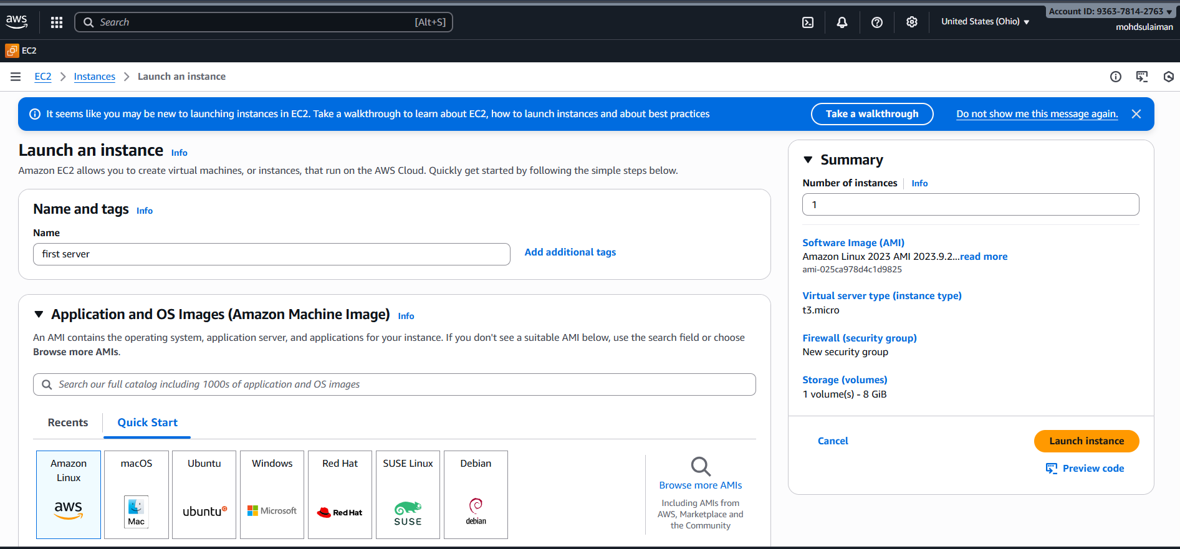
Now, we have finally created a server-apache named “server”
Open a terminal in local and add the link with ec2 server.
Ssh -i “pem.key” ec2-user@”ip”

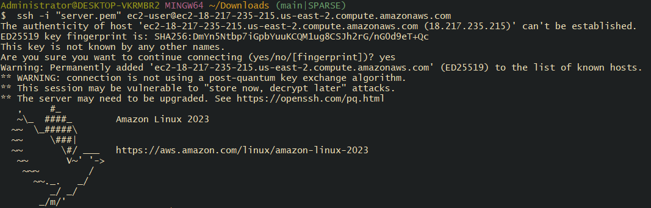
Now verify if “Apache” is installed from the script added, using command- “systemctl status httpd”
Success, the script worked and apache is installed and running.
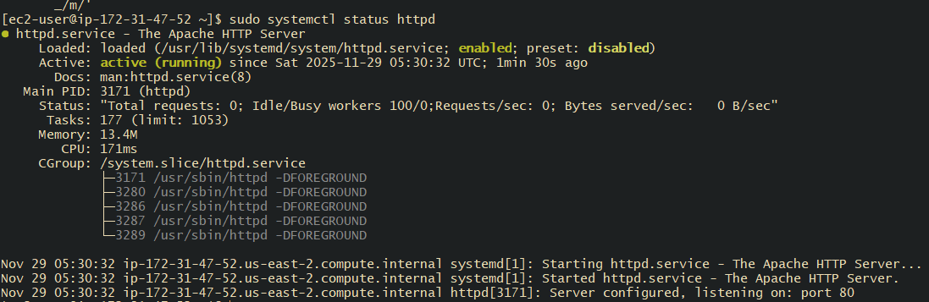
Verified the port number with ip from ec2.
Success.

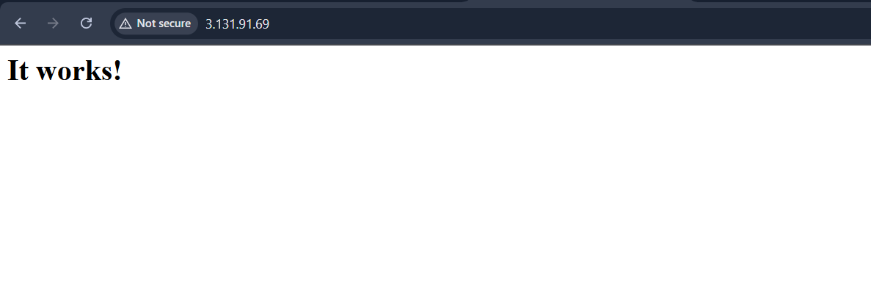
2 . Launch one EC2 using Ubuntu image and add a script in user data to install Nginx.
nstance Details:
Image: Ubuntu
Purpose: Automatically install Nginx using User Data
User Data Script Use:
Added in Advanced Settings → User Data while launching instance
Steps to install nginx on your machine
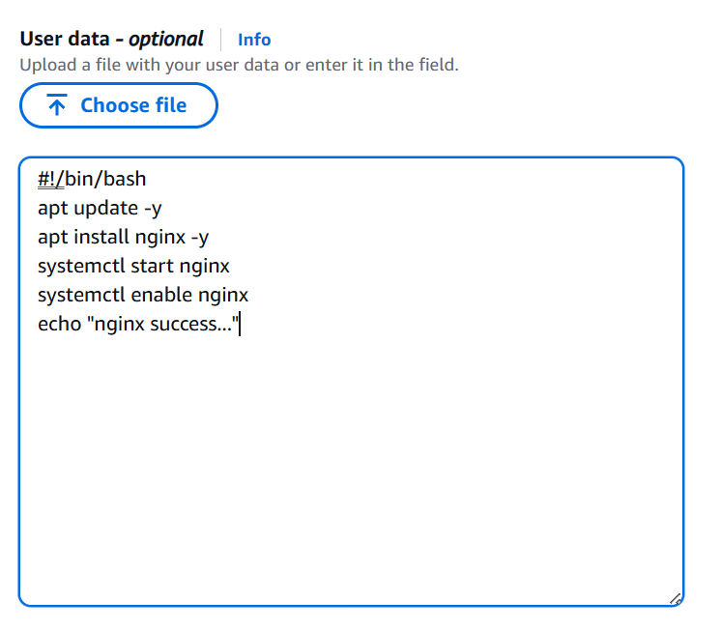
- apt update -y
- apt install nginx -y
- systemctl start nginx
- systemctl enable nginx

Launch an nginx-server instance, select the region and select the ubuntu image and disk size , in advance settings - add user data to install nginx
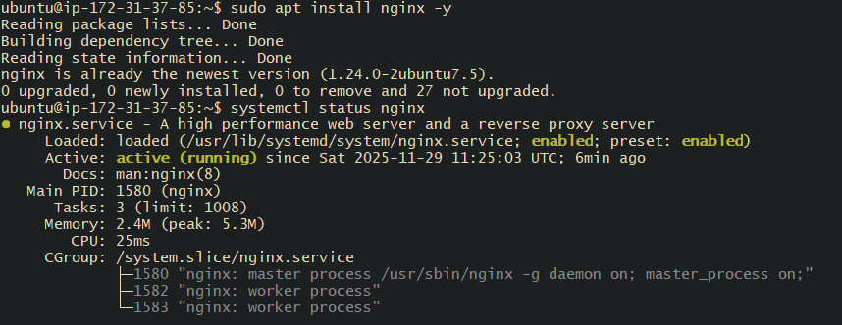
nginx is working on port 80 with IP address ( 80 is defult port of nginx)
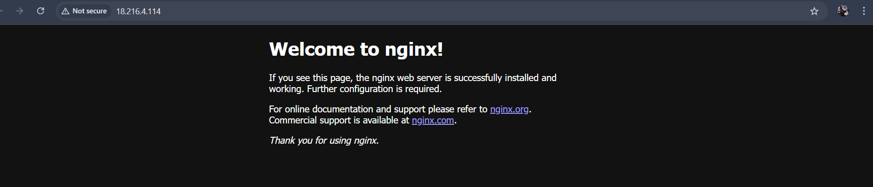

3. Launch one Windows server and install Tomcat on Windows.
To launch one windwos server and install tomcat
- Creating an instance named “windows”
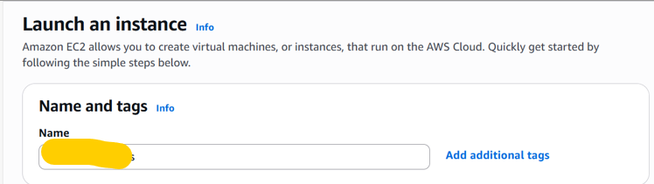
Using AMI as Windows as per the requirement.
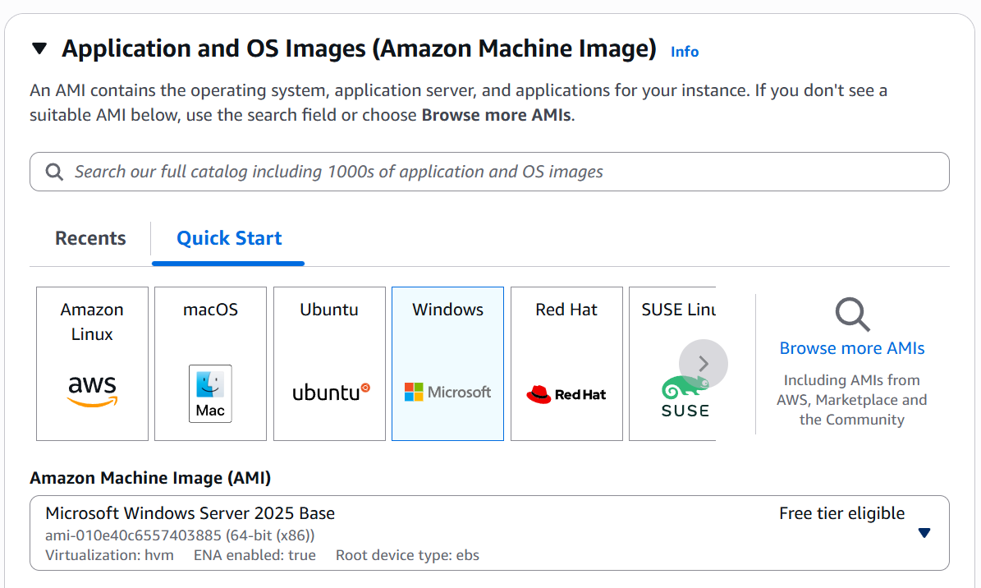
Launch Instance
Now Connect and open RDP client in the second tab and click “Set password”

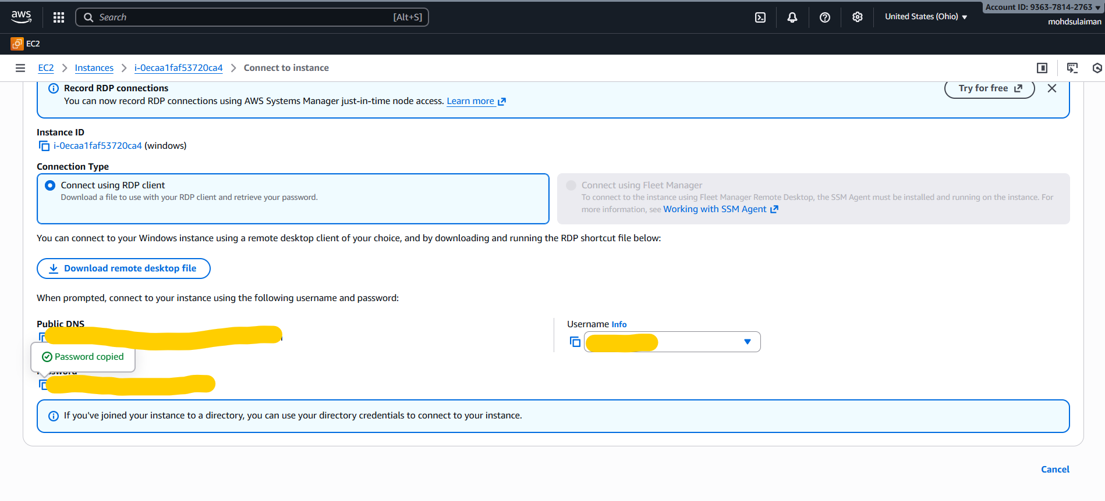
Now, “Download remote desktop file” and start the remote server.
Go to the browser and download Java in website “Adoptium” and install Java.
Make sure to download java for apache tomcat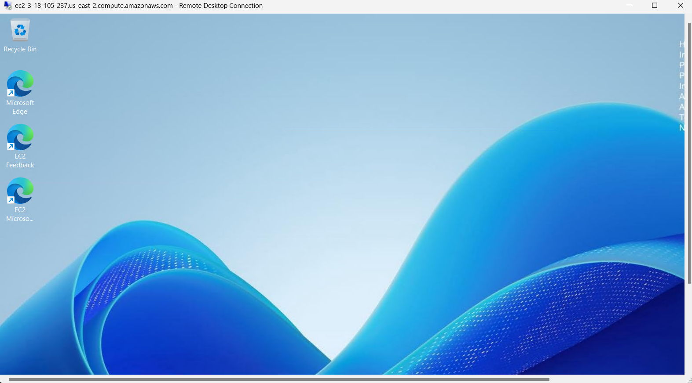

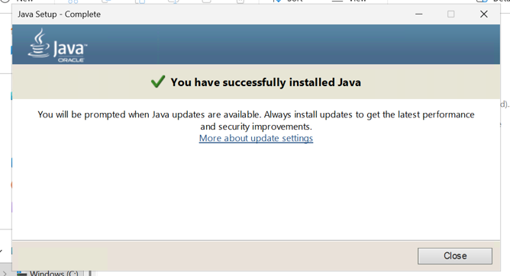

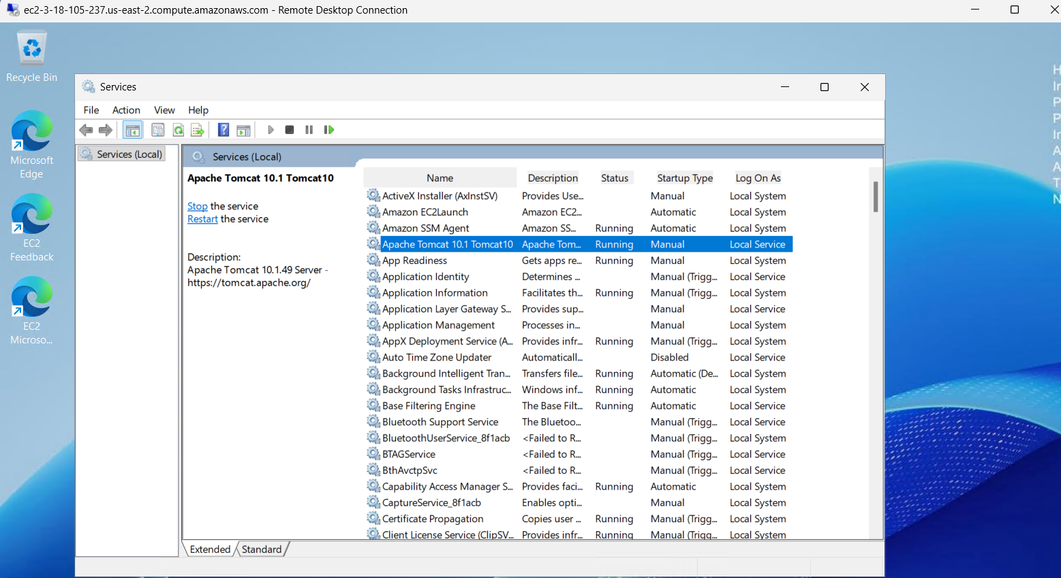
In service :- you start or stop you service ( apache tomcat )as per your requirments

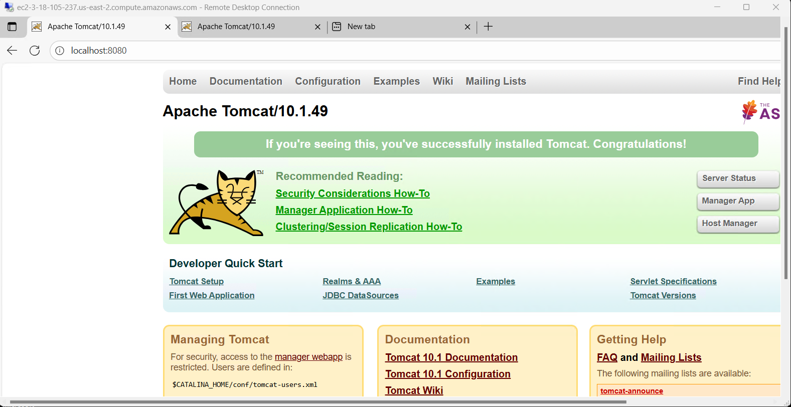

4 Take a snapshot of the instance created in Task

A Snapshot is a backup of an EBS Volume
Snapshot = Photo / Backup of your server’s disk
It contains
• Operating system (Amazon Linux)
• Apache installation
• Your user-data installed files
• Any files you had on the server

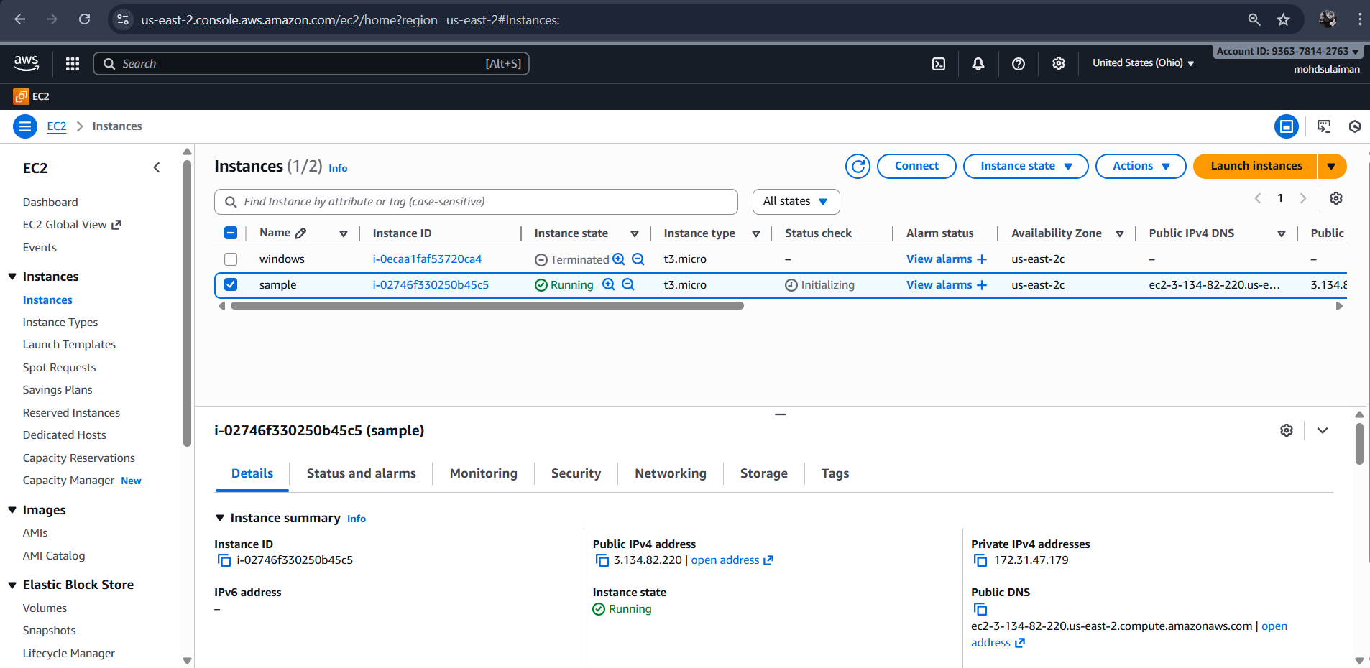

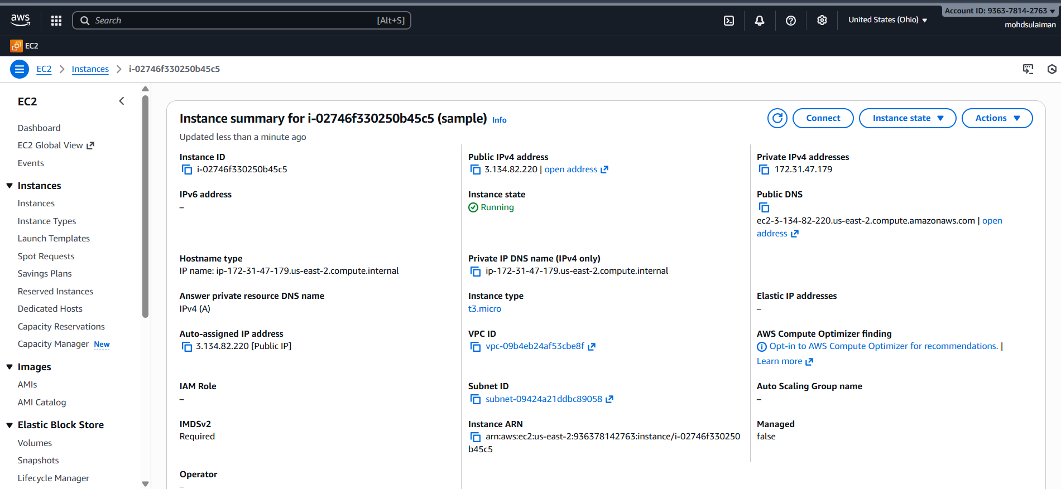

5 Assign passwordless authentication for the EC2 created
Start a Bash server in local machine and create a ssh-keygen with a command- ssh-keygen -t rsa
Copy the ssh id and paste to the command to get the ssh key generated with including .pub

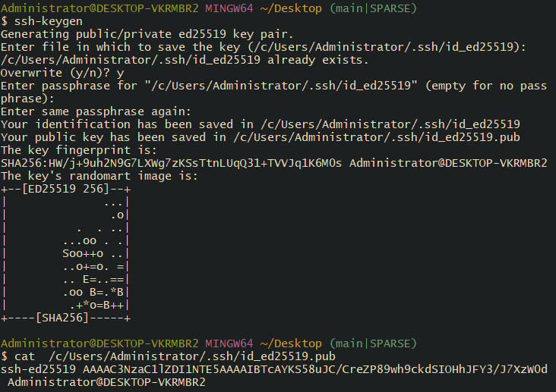

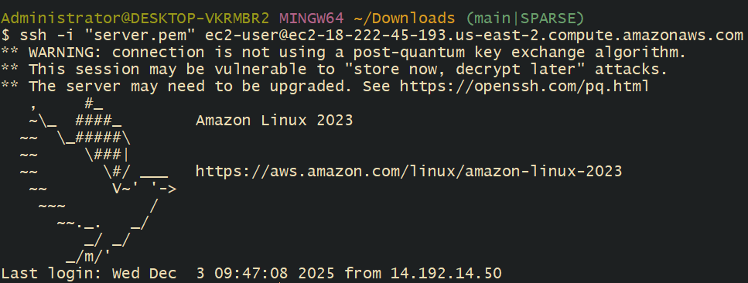

6. Launch any EC2 using the spot purchasing option
before launching a spot instance, we need to update our requirements in the left
scroll bar.
We updated the purchasing option and entered $1per hour.
Valid set to “no expiry date”
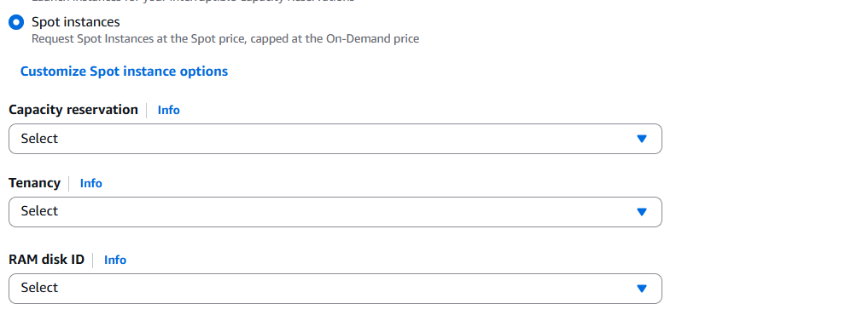
Changed “Request type”, “Instance behaviour” and Tenancy as Dedicated as I do not want to lose my project. Success- Now we launched a instance with spot purchasing options
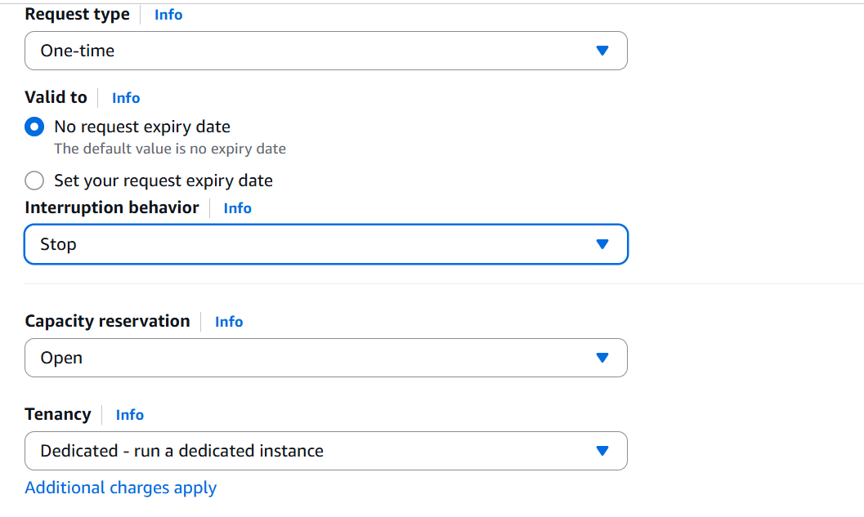

_{7.} Enable termination policy on the EC2 created
Process is simple. Select the instance and go to Actions tab.
In the Instance settings- select “Change termination protection”.

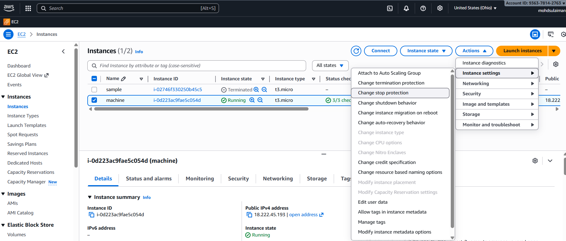
It will ask you to Save.
Now our ec-2 instance cannot be deleted. If anyone tries to delete, then they will get an error.
Success- the task is completed

8. Launch one EC2 using AWS CLI.

aws ec2 create-key-pair --key-name homekey --query 'KeyMaterial' --output text > homekey.pem
aws ec2 create-security-group --group-name home-security-group --description "My Cli Security Group"
aws ec2 authorize-security-group-ingress --group-name home-security-group --protocol tcp --port 22 --cidr 0.0.0.0/0
aws ec2 run-instances --image-id ami-0d176f79571d18a8f --count 1 --instance-type t3.micro --key-name homekey --security-groups home-security-group

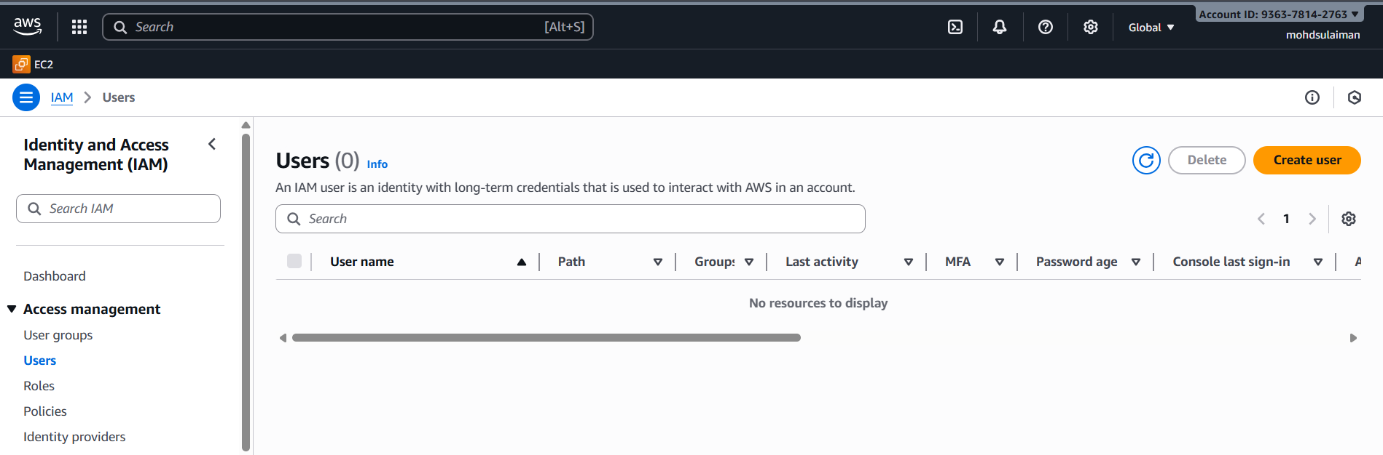
Created Access Key in Access keys section.
Access key created successfully.

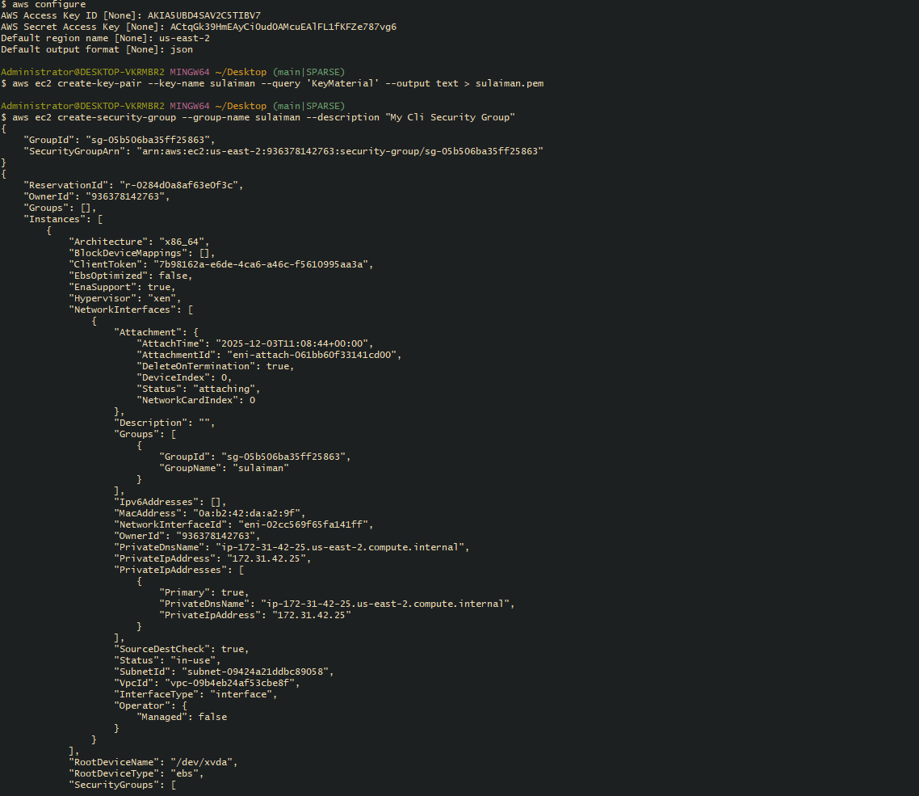

THANKS REVVING MY TASK

